  - Software Quality Assurance

Tutorial 1
In this tutorial, you will follow the principles of the Test-Driven Development methodology to develop some simple Java programs.

Introduction
Test-Driven Development (TDD) is a software development process where you write the test cases before writing the actual source code.
Instead of the traditional flow (Write Code -> Write Test -> Fix Bugs), TDD reverses it to: Write Test -> Write Code -> Fix Code.
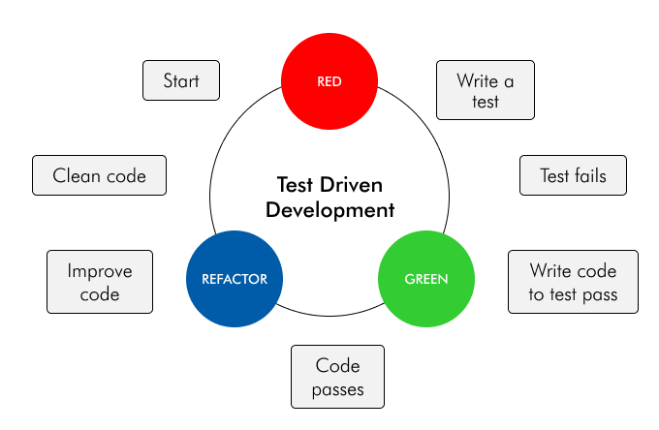
The TDD process always follows a continuous 3-step loop:
- Red (Write Test): Write a small test case for the functionality you intend to build. Run the test and ensure it fails (because the logic doesn't exist yet).
- Green (Write Code): Write just enough source code to make that test pass. The goal here is to get the “Green” test (pass) as quickly as possible; the code doesn't have to be perfect yet.
- Refactor: Look at the code you just wrote. Clean it up, optimize it, and ensure it follows coding standards, all while making sure the test remains "Green".
Key Principles of TDD:
- Test First: Never write production logic unless you have a failing test case for it.
- KISS (Keep It Simple, Stupid): Keep things simple. Only write code sufficient to pass the current test; don't over-engineer for “future features”.
- Baby Steps: Break problems down into tiny tests. Don't try to solve the whole problem at once.
- F.I.R.S.T: A good Unit Test in TDD must be:
  - Fast.
  - Isolated (One test should not depend on another).
  - Repeatable (Always gives the same result).
  - Self-Validating (Pass/Fail is automatic, no manual log checking).
  - Timely (Written just before the code).

Preparation
Create a new project
- Build system: Maven
- JDK: 21
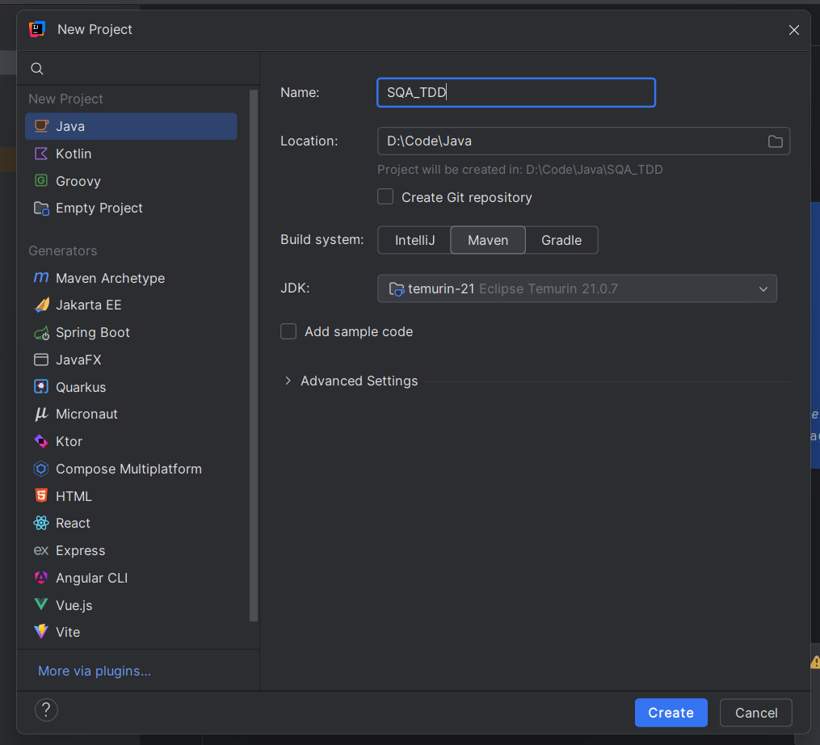
Configure JUnit Dependency
- Open the pom.xml
- Inside the <project> tags insert the following block code:
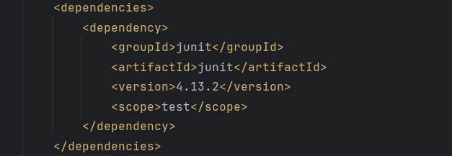

Exercise 1

Task
White a method to square every digit of a number and concatenate them.
For example, if we run 9119 through the function, 811181 will come out, because 9² is 81 and 1² is 1.
Note: The method accepts an integer and returns an integer.

Exercise 2

Task
Mark is an accountant; he wants to build a program to calculate the pre-tax price of products given a desirable sale (after-tax) price. For example:
If the sale price is $12 then the actual price should be $11.42 (because $11.42 plus 5% is approximately $12).
Tax rate is not always 5%, it depends on the sale price. If sale price is less than $100, tax is 5% but if sale price is $100 or higher, tax is 10%.
Write a program to get the exptected sale price from the keyboard and display the pre-tax price, rounded to 2 decimal places. The rounding method should always reduce, not increase the resulting price. The program is allowed to have an error margin of $0.01 (1 cent).

Exercise 3

Task
Using TDD, write a program to calculate taxi fares from the distance (in KM) entered by user. Following are the rules to calculate taxi fares:
- The minimum fare is 10,000 VND.
- The first kilometer costs 15,000 VND.
- The next 9 kilometers (from 2nd to 10th) costs 12,000 VND each.
- From the 11th kilometer, the cost is 11,000 VND per km and reduced by 500 VND every other 10 KMs until 7,000 VND.
The travel distance is entered by the user in KMs. The program only accepts travel distances no more accurate than 10 meters. The calculated fee is rounded up to the nearest thousand (VND).

Exercise 4

Task
You are given a string of space separated numbers and have to return the highest and lowest number.
Examples:
highAndLow("1 2 3 4 5") // return "5 1"
highAndLow("1 2 -3 4 5") // return "5 -3"
highAndLow("1 9 3 4 -5") // return "9 -5"
Notes:
- There will always be at least one number in the input string.
- Output string must be two numbers separated by a single space, and highest number is first.

